: + 36 (70) 378-0544
Address: 6728 Szeged, Repülőtér Bajai út. : H-6728 Szeged, Kazinczy u. 2

Association of Hungarian Reservists

Fellowship Association of Hungarian Parachutists

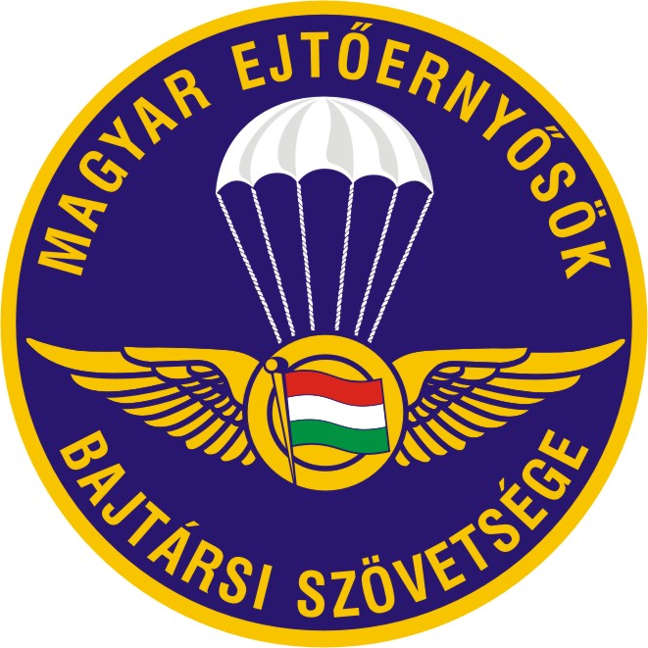



XXII. MATASZ-MEBSZ CUP INTERNATIONAL ACCURACY LANDING PARACHUTING COMPETITION

EAST EUROPEAN ACCURACY CUP

17-19 September 2021
Szeged

ANNOUNCEMENT OF COMPETITION

1/ Organisers

- DÉLVIDÉKI AERO CLUB 1930;
- CITY of SZEGED;
- ASSOCIATION of HUNGARIAN RESERVISTS;
- FELLOWSHIP ASSOCIATION OF HUNGARIAN PARACHUTISTS;

2/ The aim of competition is

- to provide an opportunity for competition for members of Hungarian and other European parachuting clubs;
- to maintain and develop international relationships;
- to increase the popularity of Szeged city and Csongrád county;
- to facilitate relationship between parachuting clubs;
- to boost the popularity and represent the activity of the Fellowship Association of Hungarian Parachutists.

3/ Patrons of the competition

Patrons: Dr. Tibor Benkő Minister of National Defence
- Dr. István Simicskó Chairman of Sport Associaton of National Defence,
- Ernő Széles r. major general Chairman of MATASZ,
- Dr. Gábor Boldizsár colonel Chairman of MEBSZ,
- Dr. Tünde Juhász Government Representative of Csongrád county
- Gábor Balázs Chairman of Délvidéki Aero Club 1930.
- Ferenc Bátor lieutenant-colonel MH. 5 DD Pkh. Garrison Commander,
- László Antal colonel 37. II. Rákóczi F. Mü. epk.

4/ Venue, date and staff of the event

Location: Szeged Airport. Hungary Szeged, Repülőtér Bajai út
Coordinate: 4615 02,87N 02005 20,62E
Date: 17-19. september 2021
Director of the event: Ret. Lt. Col. Gyula Várnagy
Deputy director of the event: Ret. Maj. Antal Kiss
Chief organiser: József Csorba
Chief judge: Ret. Lt. Col. Gyula Várnagy (HUN) FAI/CISM judge

5/ Closing date for entries

Closing date for entry: 10. september. 2021

6/ Entry fee

Entry fee: 120 Euro/person. The entry fee is free of VAT.
The entry fee includes:
      - the price of parachuting rounds;
      - the cost of organization.
.

Bank account of the organiser:

7/ Entries should be made at

www.tandemszeged.hu and click on: XXII. MATASZ Kupa regisztráció
E-mail: csorbajozsef67@gmail.com

8/ Conditions of entry

- Participation is based on invitation;
- The organisers accept the entries of the first 15 teams;
- Teams consist of 4 (four) competitors;
- Teams can be mixed (male-female) and team members may be members of different clubs;
- Entries can be made on the entry form attached to this announcement;

9/ Rules of competition

- The event is an accuracy landing competition;
- The competition rounds will be team accuracy landing jumps, and the individual ranking will be determined based on the individual results of the team rounds;
- Number of jumps: max. 8, min. 4;

- The exit altitude is between 900-1100 m;
- Aircraft: C-182;
- Pilots: Imre Farkas, Gábor Nacsa,

Judging
The landing point is the first point of contact with the surface as decided by the judges according
Landing is measured up to 16 cm (pts) by the AMD; landing on the control pad will give the score
of 17 cm (pts); landing on the artificial pit (outside the control pad) will give the measure of 18 cm
(pts); landing outside of the artificial pit will give the score of 19 cm (pts).
0-16
17 on the control pad
18 artificial pit (tuffet)
19 out of artificial pit (tuffet)

10/ Prizes

- Team accuracy I-III.;
- Individual accuracy I-III.;
- The best foreign competitor;
- The best female competitor;
- The best competitor from Szeged;

11/ Programme

17 september 2021 (Friday)
08:00 – 12:00 training jumps (12 Euro/jump);
12:00- 13.30 registration,
14:00 – 18:00 competition rounds;

18 september 2021 (Saturday)
07:00 – 18:00 competition rounds;
11:00 opening ceremony
19:30 dinner;

19 september 2021 (Sunday)
07:00 – 12:00 competition rounds;
13:00 announcement of results, closing ceremony.

12/ General information

12/a Documents

At registration the competitors are expected to present the following documents:

- Parachutist logbook;
- FAI licence (Parachuting licence);
- Sport licence;
- Medical certificate;
- Insurance;
- Documents of the equipment.

The licences, certificates and other documents will be checked by the organizers.
Please note, that every document should be valid until the closing date of the competition.
In any question regarding the competition and not specified in this announcement, the FAI code will be followed.
The chief instructor of every parachuting club concerned is to declare that the competitors possess the skills necessary to participate in an accuracy landing competition.

12/b Accommodation

- 10 Euro/night/person.
- Camping site in the courtyard of the airfield (with shower and WC)
5 Euro/night/person.

Please indicate on the entry form if you need accommodation!

13/ Protest

Protests have to be submitted to the chief judge in writing, no later than 30 minutes after the publication of the results of the jump in question, with reference to the relevant points of FAI Sporting Code.

Protest fee: 20 Euro

The organisers reserve the right to change the programme.

For further information call: József Csorba +36/70 378-0544

Done at, Szeged 05. august 2021
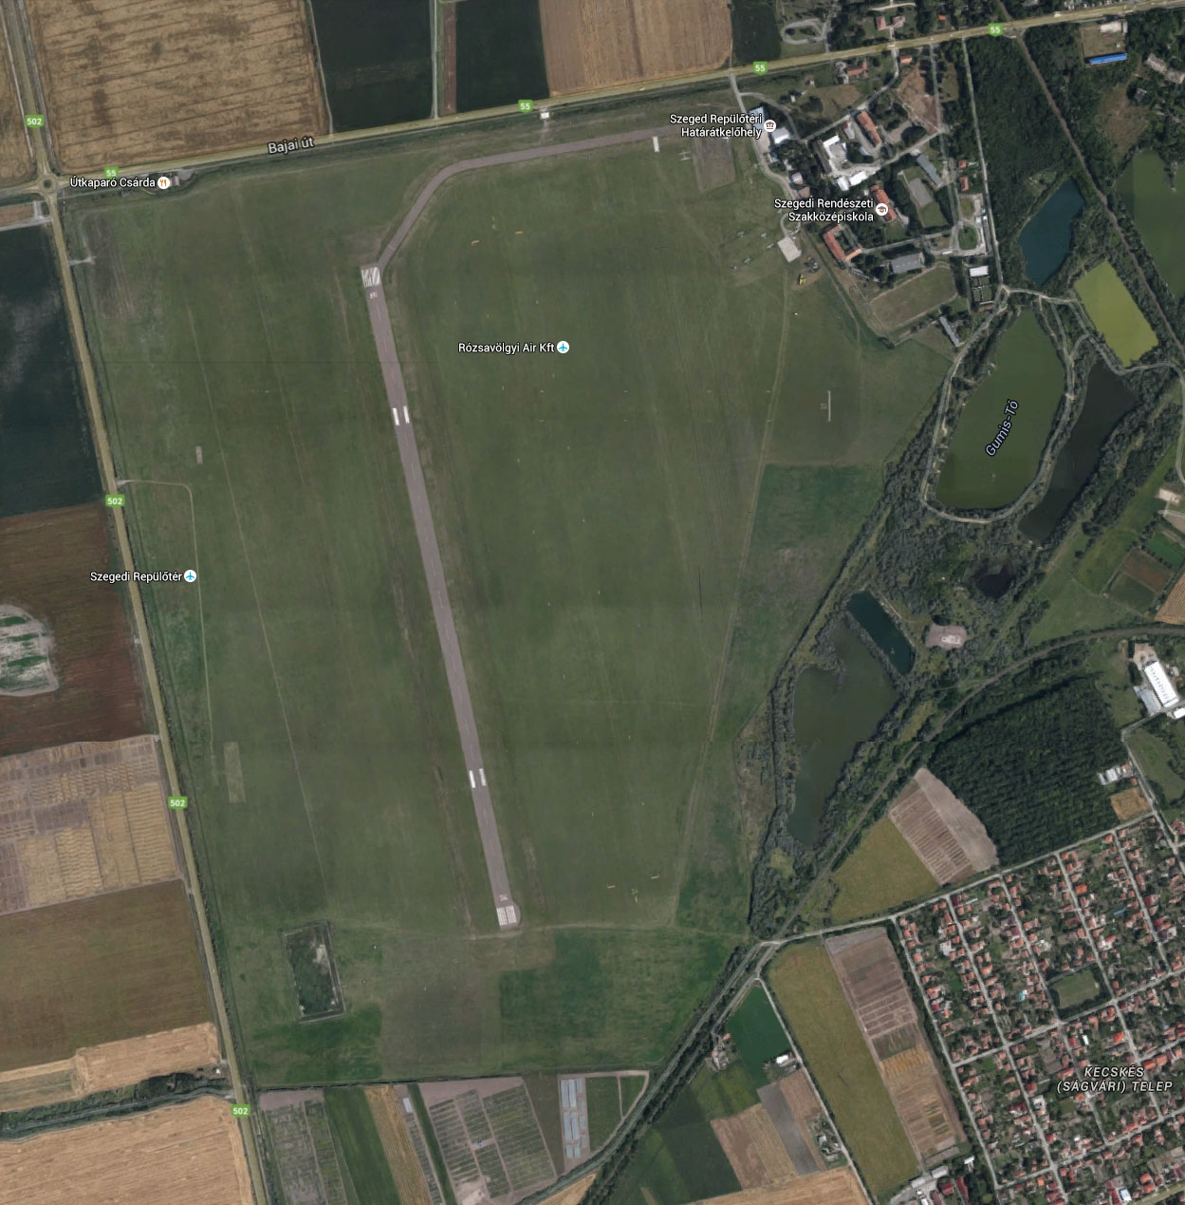

Location: Szeged Airport. Hungary Szeged, Repülőtér Bajai út
Coordinate: 4615 02,87N 02005 20,62E

Approach
The airport is located on the western side of the city, 2km far from the centre, next to Road 55 (Bajai road).
You have to leave M5 highway at exit 166, turning toward Szeged, you will reach the area of the airport 5km far from the highway exit on the right side.

www.airportszeged.hu/

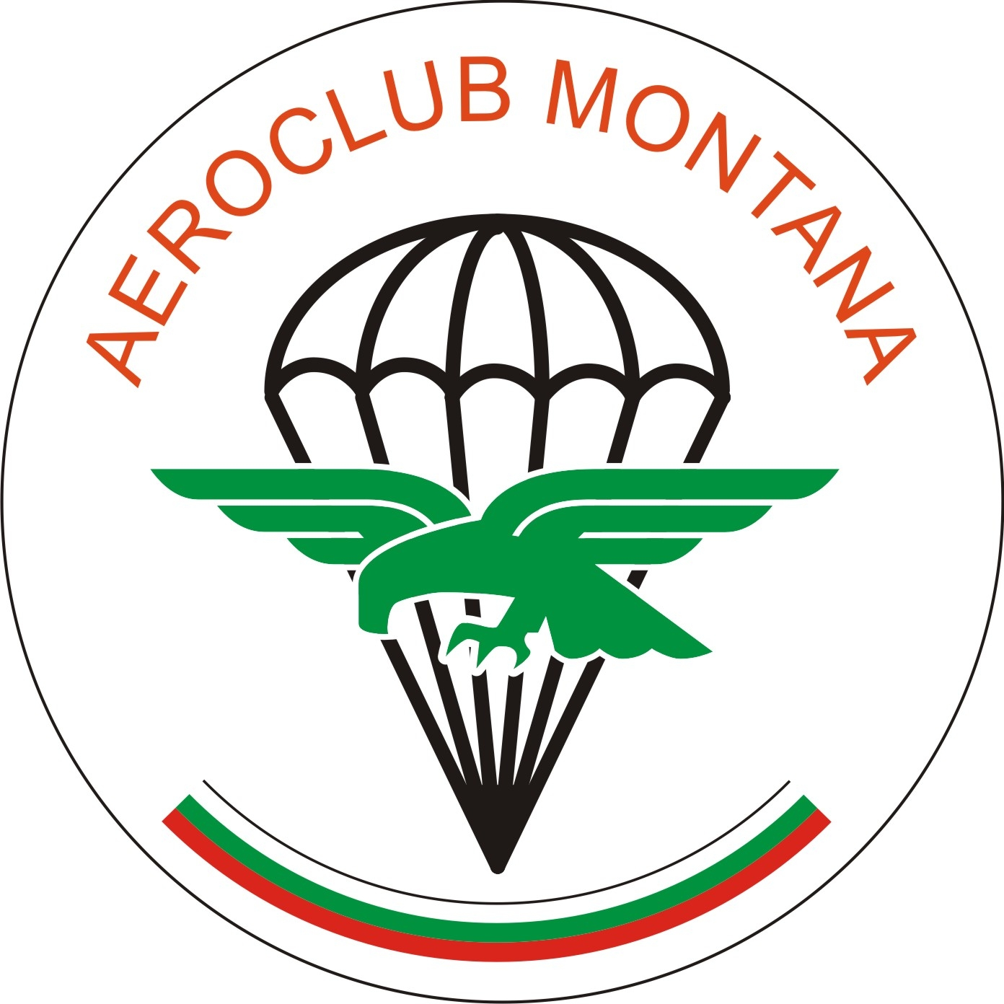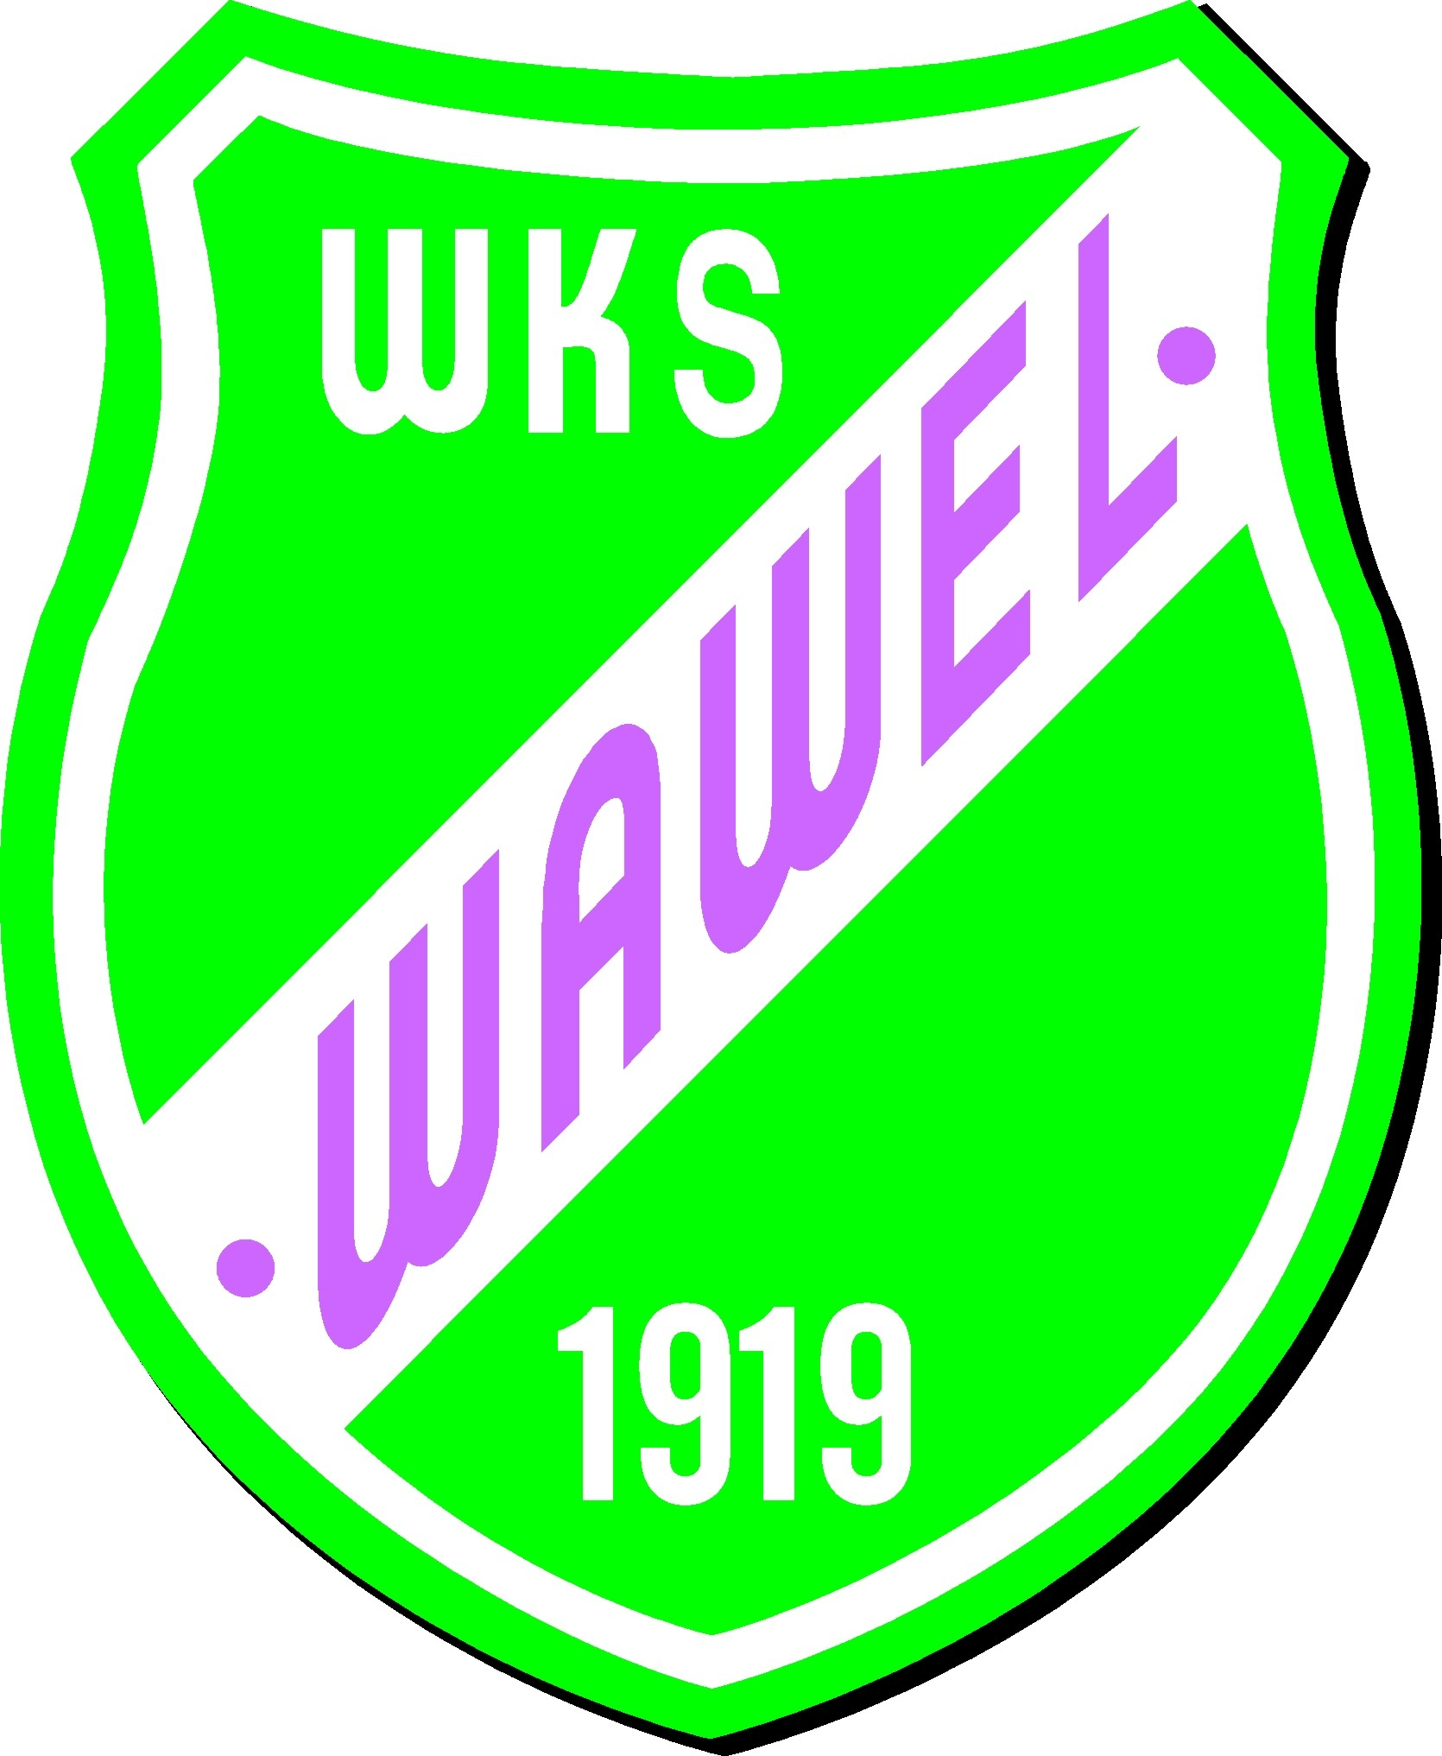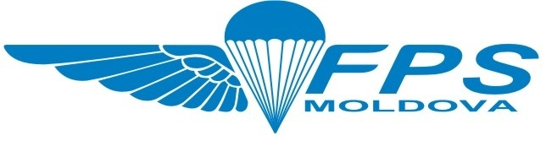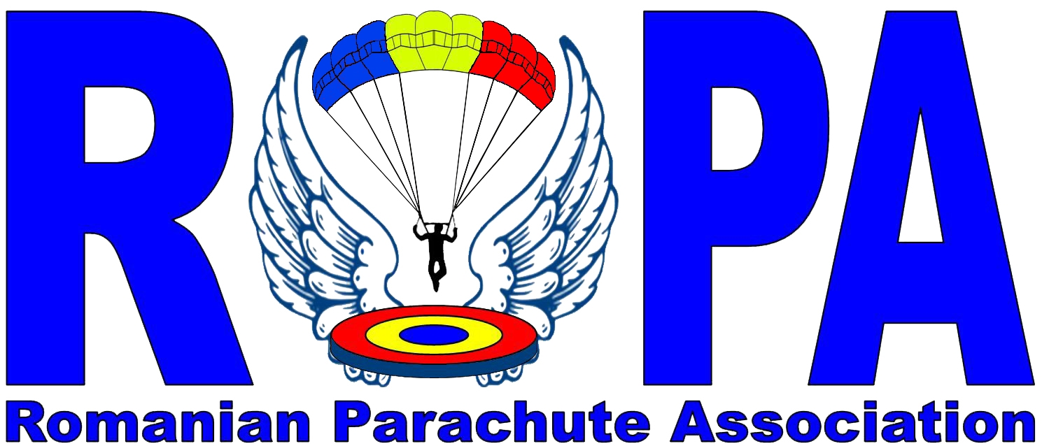

XXII. MATASZ-MEBSZ CUP INTERNATIONAL ACCURACY LANDING PARACHUTING COMPETITION

Nevezési lap
(Entry form)

Csapat neve:
(Name of team)

Ország:
(Country)

Résztvevők
(Participants)

Név  Name | Date of Birth | Anyja neve  Mother’s name | Fő eje. típus  gyári szám | Aláírás  Signature of competitor

Aláírásommal nyilatkozom, hogy rendelkezem az ejtőernyős ugráshoz szükséges mind a személyes, mind a felszerelés engedélyekkel és okmányokkal. Felszerelésem karbantartott, üzemképes ejtőernyős ugrásra alkalmas

Hereby I state that I have all the personal and of the equipment permissions and dokuments, witch are necessary for the parashute jump, my equipment is well maintained ready for work and capable of parachute jump.

